1. Open MAINTENANCE01-01. Modify the working program to meet the new specifications described in the comments.

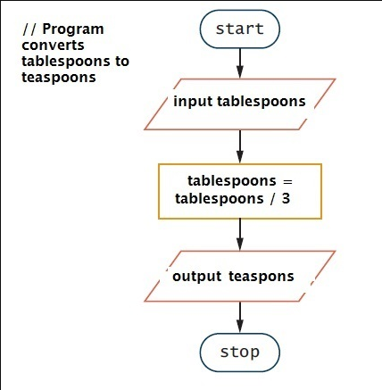

There are some errors in the flowchart:

The word "teaspons" is misspelled, it should be "teaspoons".

The rectangle that says "tablespoons = tablespoons / 3" should be "teaspoons = tablespoons / 3" because we want to convert "tablespoons" to "teaspoons".

1. Create the logic for a Mad Lib program that accepts four words from the input and then uses them to create and display a short joke or poem.

1. Accept input: The program will first ask the user for four words that will be used to fill in the blanks in the joke or poem.

2. Create templates: I will prepare in advance some templates for jokes or poems, which contain the blanks to be filled in. These blanks are usually various types of words, such as nouns, verbs, adjectives, and so on.

3. Fill the templates: Based on the words entered by the user, fill the templates with them. Make sure to fill the blanks with the right type of words to ensure that the resulting joke or poem is smooth and funny.

4. Show Result: Show the filled template to the user so that they can enjoy the generated joke or poem.

Code in ‘Practice Exercise Chapter 1.txt’.